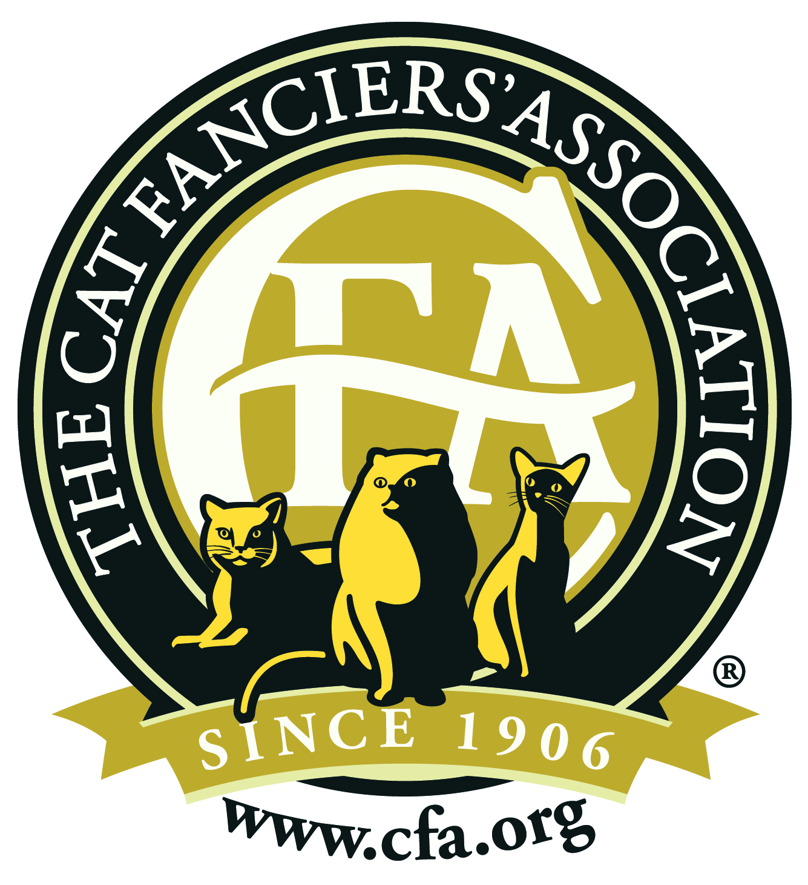
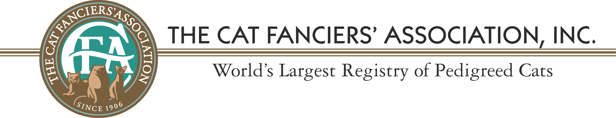

FOR IMMEDIATE RELEASE
Date: Phone: Email:

FOR IMMEDIATE RELEASE

NAME OF CITY OR TOWN HERE Cat Takes Top International Honors in The Cat Fanciers’ Association

DATE, CITY. OWNER NAME of CITY OR TOWN was in Toronto, Ontario Canada over the weekend to accept the NUMBER Best International Cat for the Cat Fanciers’ Association (CFA). TITLE NAME OF CAT was among 25 top honorees at CFA’s Awards Banquet at the Westin Harbour Castle Hotel on July 4, 2015. “NICKNAME OF CAT”, bred and owned by NAME is a COLOR, PATTERN, BREED of cat who defeated more than 10,000 cats from around the world for the honor. This is the NUMBER international win for OWNER LAST NAME, (who was awarded NUMBER best cat in YEAR).

YOU CAN PUT A QUOTE HERE ABOUT HOW EXCITED YOU ARE, AND HOW THE CAT IS AN EXCELLENT REPRESTANTION OF THE BREED.

Among the other top winners were cats from the United States, Russia, Italy, China, France and Spain.

The Cat Fanciers’ Association, Inc.™ (CFA) was founded in 1906 as a not-for-profit association of member clubs and is the world’s largest registry of pedigreed cats. CFA’s mission is to preserve and promote the pedigreed breeds of cats and to enhance the well being of ALL cats. CFA promotes education, responsible cat ownership and proper care to the owners of millions of cats worldwide. CFA and its affiliate clubs work nationally with local shelters to help humanely reduce homeless and feral cat populations and to encourage voluntary neuter/spay of pet cats. To learn more about the Cat Fanciers’ Association, the pedigreed breeds of cats, or to find the nearest CFA cat show, visit their web site at www.cfa.org

